**Goal**

Analyze the CSS Frameworks currently in use at other companies, to help guide the decisions making process for User Interface Solutions at TechData.

**Summary**

Overall analysis of the 16 companies showed that all Companies used a CSS Framework as a part of the Frontend Solution. Dominant solutions, 75% percent of the companies used a Custom CSS Framework and 25% Used Bootstrap.

**Analysis of CSS Frameworks**

**Figure 1. Table and Pie chart showing companies and CSS Framework solutions with AEM.**

|  |  |
| --- | --- |
| COMPANY | CSS FRAMEWORK |
| Samsung­ | Custom Framework |
| Salesforce | Custom Bootstrap |
| HP | Custom Framework |
| CDW | Custom Framework |
| LinkedIn | Bootstrap |
| FedEx | Bootstrap |
| Chase | Bootstrap |
| McDonalds | Bootstrap |
| Dell | Custom Framework |
| Visa | Custom Bootstrap |
| Deloitte | Custom Framework |
| Mastercard | Custom Framework |
| KAO | Custom Framework |
| Australia Tourism | Custom Framework |
| Scandinavian Airlines | Custom Framework |
| Adobe | Custom Framework |

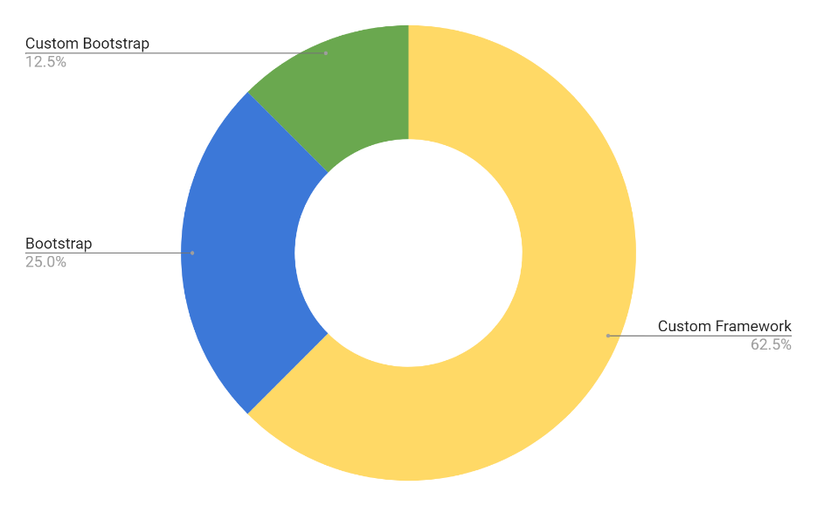

Custom are references to CSS Frameworks built specifically for the company.

Custom Bootstrap are references to customized CSS Frameworks built on a Bootstrap foundation.

Bootstrap references out the box CSS framework.

**Data review**

Based Figure 2. There is a trend on CSS Frameworks; Custom Frameworks led the solutions at 62.5 % and 27.5% used a Bootstrap or Custom solution. Using the data. Listed below are the three solutions.

1. Build a Custom Framework.
2. Build a Custom Framework using Bootstrap.
3. Use Bootstrap out of the box.

**Analysis CCS Framework solutions for 3 of the 16 companies that offer similar services to Tech Data.**

**Figure 2. Table showing CSS Framework solution for CDW, DELL and HP.**

**Data Review**

Based on Figure 4. Companies that offer similar products and solutions chose to create a custom framework.

**Data Collection and Analytics Tools**

**Data Sources**

The companies analyzed were found using 2 sources.

1. <https://www.featuredcustomers.com/vendor/adobe-experience-manager/case-studies> a website that is a customer reference platform for B2B business software and services. It helps potential B2B buyers to search and discover business software and services through vendor validated customer reference content such as customer testimonials, success stories, case studies, and customer videos.
2. <https://whatcms.org/c/Adobe-Experience-Manager>

**Analytic Tools**

The companies were analyzed using analytic tools and then the source code manually reviewed to verify the quality of the analysis.

1. <https://www.wappalyzer.com/>

Programmatic access to technographic data. The **Wappalyzer** APIs provide instant access to website technology stacks, contact details and social media profiles.

1. <https://www.whatruns.com/>

What Runs shows you pretty much everything that powers a website. Web apps they pay for, CDN they are hosted on, how they track their visitors, WordPress plugins, fonts – you name it!

1. Browser Inspector, every modern web browser includes a powerful suite of developer tools. These tools do a range of things, from inspecting currently loaded HTML, CSS and JavaScript to showing which assets the page has requested and how long they took to load.

**Figure 3. List of Companies and Website links using AEM and Link to Analysis.**

|  |  |
| --- | --- |
| Samsung  <https://www.samsung.com/us/>  <https://www.wappalyzer.com/lookup/samsung.com> | Salesforce  <https://www.salesforce.com/>  <https://www.wappalyzer.com/lookup/salesforce.com> |
| HP  <https://www8.hp.com/us/en/home.html>  <https://www.wappalyzer.com/lookup/www8.hp.com> | CDW  <https://www.cdw.com/>  <https://www.wappalyzer.com/lookup/cdw.com> |
| LinkedIn  <https://www.linkedin.com/>  <https://www.wappalyzer.com/lookup/linkedin.com> | FedEx  <https://www.fedex.com/en-us/home.html>  <https://www.wappalyzer.com/lookup/fedex.com> |
| Chase  <https://www.chase.com/>  <https://www.wappalyzer.com/lookup/chase.com> | McDonald’s  <https://www.mcdonalds.com/us/en-us.html>  <https://www.wappalyzer.com/lookup/mcdonalds.com> |
| Dell  <https://www.delltechnologies.com/en-us/index.html>  <https://www.wappalyzer.com/lookup/delltechnologies.com> | Visa  <https://usa.visa.com/>  <https://www.wappalyzer.com/lookup/usa.visa.com> |
| Deloitte  <https://www2.deloitte.com/us/en.html>  <https://www.wappalyzer.com/lookup/www2.deloitte.com> | Mastercard  <https://www.mastercard.us/en-us.html>  <https://www.wappalyzer.com/lookup/mastercard.us> |
| KAO  <https://www.kao.com/global/en/worldwide.html>  <https://www.wappalyzer.com/lookup/kao.com> | Australia Tourism  <https://www.australia.com/en-us>  <https://www.wappalyzer.com/lookup/australia.com> |
| Scandinavian Airlines  <https://www.flysas.com/en/>  <https://www.wappalyzer.com/lookup/flysas.com> | Adobe  <https://www.adobe.com/>  <https://www.wappalyzer.com/lookup/adobe.com> |

**­**

**Technologies used by CDW, DELL and HP**

**CDW**  **Dell Technologies**

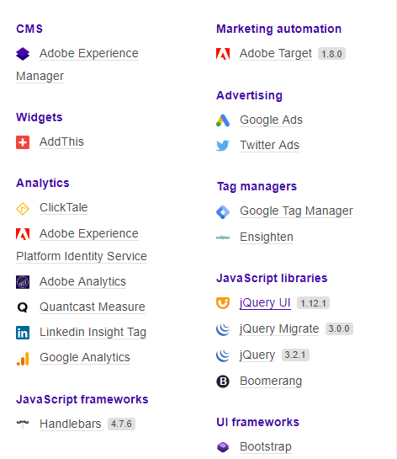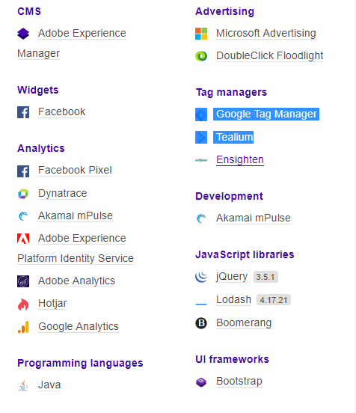<https://www.cdw.com/><https://www.delltechnologies.com/en-us/index.html>

**HP**

<https://www8.hp.com/us/en/home.html>

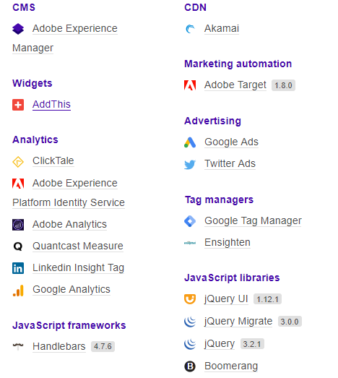

**Please not that source code reviews indicated that neither used Bootstrap but instead created a Custom CSS Framework with similar class codes to Bootstrap.**